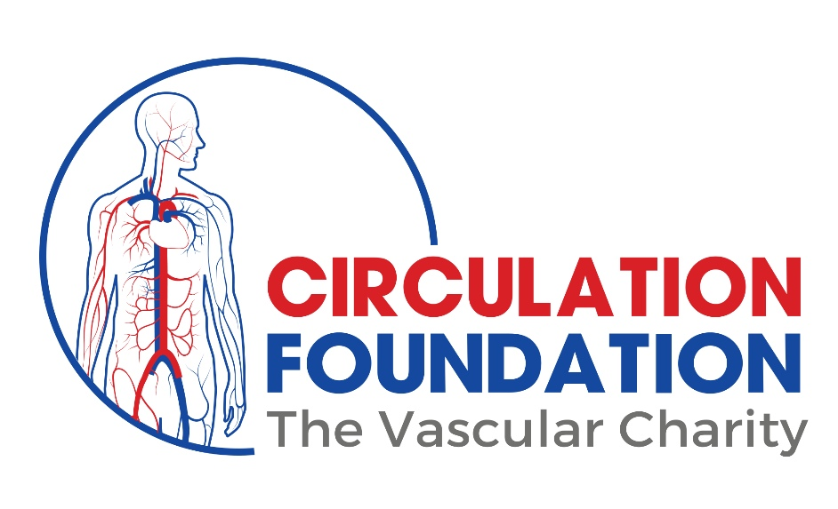Sponsorship and Gift Aid Declaration Form
Please sponsor me (name of participant) ___________________________
Name of fundraising event: __________________________________________________________________
In aid of (name of charity) _____________________________________________
If I have ticked the box headed ‘Gift Aid ‘, I confirm that I am a UK Income or Capital Gains taxpayer. I have read this statement and want the charity named above to reclaim the tax on the donations detailed below, given on the date shown. I understand that if I pay less Income Tax / or Capital Gains tax in the current tax year than the amount of Gift Aid claimed on all of my donations, it is my responsibility to pay any difference. I understand the charity will reclaim 25p of tax on every £1 that I have given.
The Body Walk
Circulation Foundation
Remember: You must provide your first name, surname, home (not work) address, postcode and Gift Aid for the charity to claim tax back on your donation.
Sponsor’s FULL NAME (first name & surname) | Sponsor’s HOME address  (please don’t give your place of work if you are Gift Aiding your donation) | Postcode | Donation Amount £ | 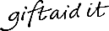  Date Paid
Joe Bloggs | 101 Charitable Giving Street | CH4R 1TY | £10.00 | 01/01/19

Sponsor’s FULL NAME (first name & surname) | Sponsor’s HOME address  (please don’t give your place of work if you are Gift Aiding your donation) | Postcode | Donation Amount £ | Date Paid
Joe Bloggs | 101 Charitable Giving Street | CH4R 1TY | £10.00 | 01/01/19
 |  | Total:

